1. 
2. Thread class has a sleep() method that can pause the execution of thread.
3. We can use this method to simulate the long running operation when downloading a file. 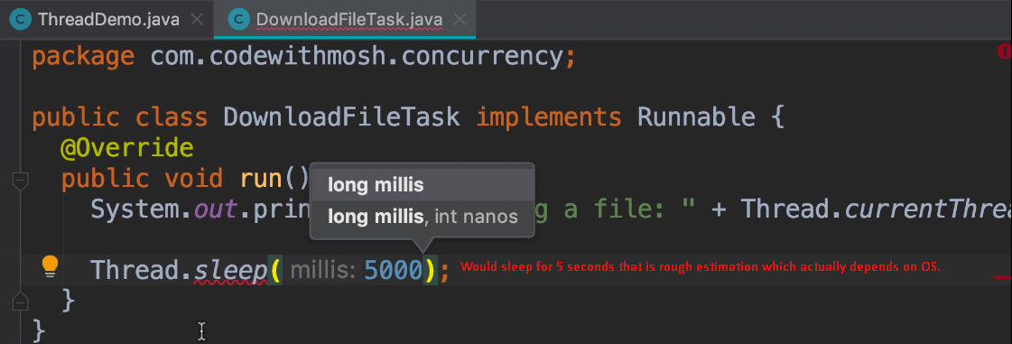
4. What if you want to run 1000 tasks concurrently? My machine has 4 cores and therefore 8 threads in total available. Well, JVM has something called **Thread Scheduler.** The job of this scheduler is to decide what thread has to run and for how long. If you have more tasks than the available threads, the scheduler switches b/w the tasks giving each task a slice of CPU time. This happens so fast that it gives us an illusion that each task is executing in parallel.